Database **workbook** and its tables

show tables

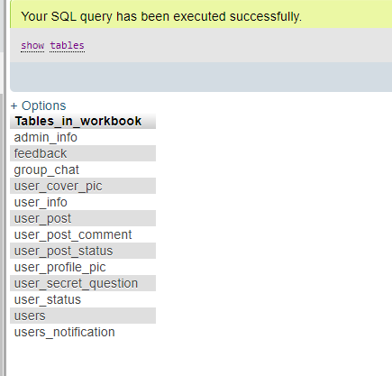

Create Table with set of column names and type of data and size of it includes if any primary or foreign keys

CREATE TABLE `users_notification` (

`notification_id` int(7) NOT NULL AUTO_INCREMENT,

`user_id` int(7) NOT NULL,

`notification_txt` varchar(120) NOT NULL,

`notification_time` varchar(30) NOT NULL,

PRIMARY KEY (`notification_id`),

KEY `user_id` (`user_id`)

)

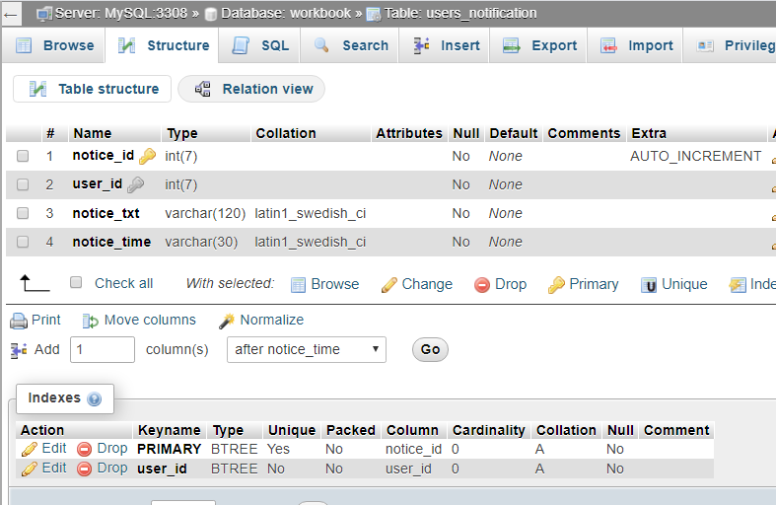

List the users who are Males

[SELECT](http://localhost/phpmyadmin/url.php?url=https://dev.mysql.com/doc/refman/5.5/en/select.html) Name,Email,Gender,Birthday_Date FROM `users` WHERE Gender='Male'

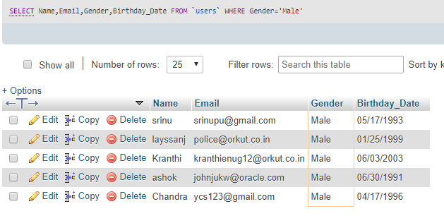

------------------------------------------------------------------------------------------------------------------------------------------

Delete Duplicate rows from the table user_security_question

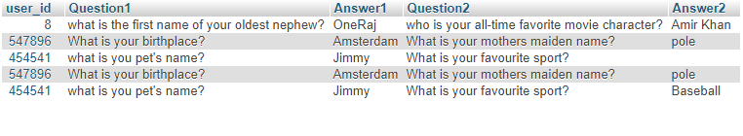

SQL query to delete duplicate rows:

DELETE from user_secret_question

WHERE Answer2 not in

(

SELECT MAX(user_id)

FROM user_secret_question

GROUP BY user_id

);

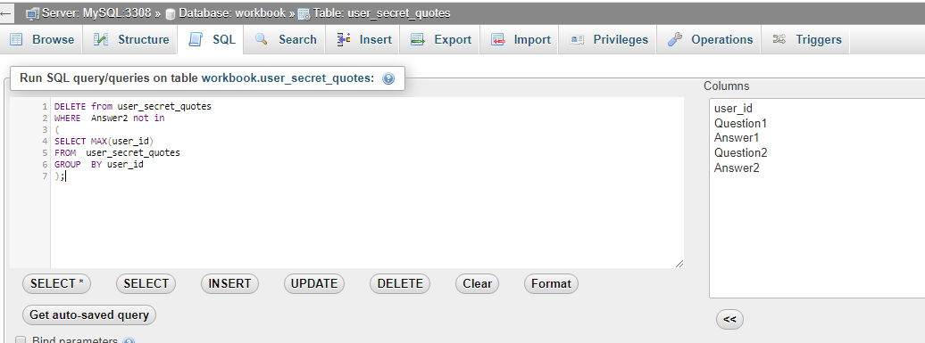

Result:

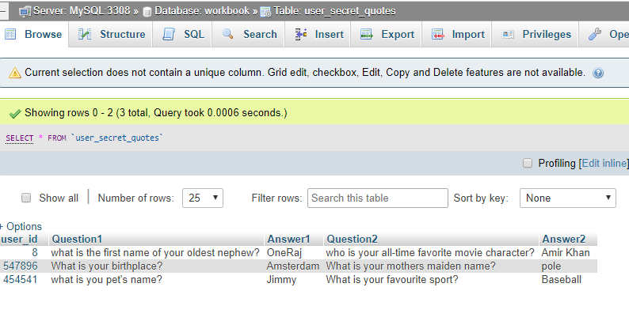

Insert Data into the tables

INSERT INTO `security_question` (`user_id`, `Question1`, `Answer1`, `Question2`, `Answer2`) VALUES

(8, 'what is the first name of your oldest nephew?', 'OneRaj', 'who is your all-time favorite movie character?', 'Amir Khan');

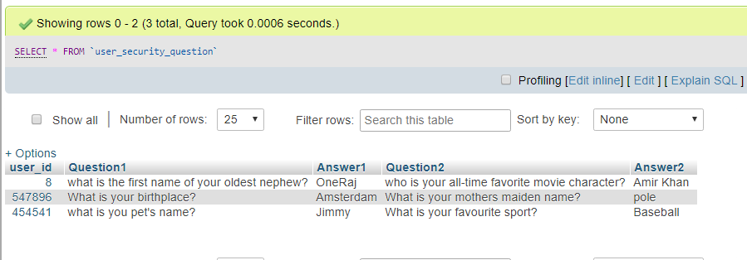

-----------------------------------------------------------------------------------------------------------------------------------------

User information table:

SQL query:

describe user_info;

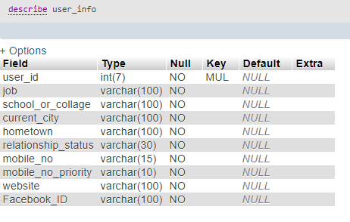

------------------------------------------------------------------------------------------------------------------------------------------

Rename Table name in workbook database;

Old table name

[RENAME](http://localhost/phpmyadmin/url.php?url=https://dev.mysql.com/doc/refman/5.5/en/rename-table.html) [TABLE](http://localhost/phpmyadmin/url.php?url=https://dev.mysql.com/doc/refman/5.5/en/rename-table.html) `workbook`.`user_secret_questions` TO `workbook`.`user_secret_question`;

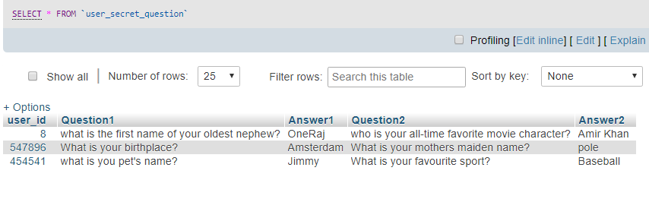

------------------------------------------------------------------------------------------------------------------------------------------

TO VIEW the Notification received by creating INNER join between user and users’ notifications table

SELECT users_notification.notice_txt, users.Name, users_notification.notice_time

FROM users_notification

INNER JOIN users ON users_notification.user_id=users.user_id;

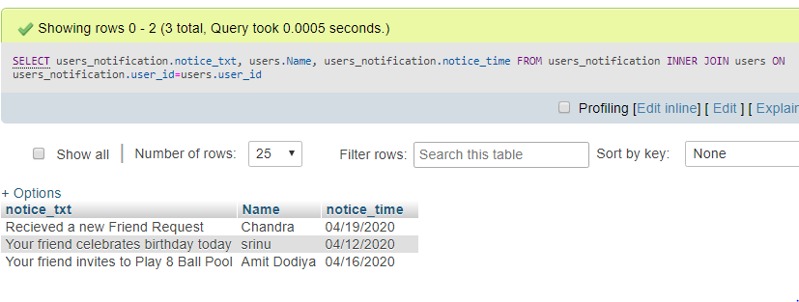

To see the POSTS made by the single user on their own profile

[SELECT](http://localhost/phpmyadmin/url.php?url=https://dev.mysql.com/doc/refman/5.5/en/select.html) users.Name,users.Birthday_Date,user_post.post_txt,user_post.post_time,user_post.post_pic from users INNER JOIN user_post ON users.user_id=user_post.user_id [AND](http://localhost/phpmyadmin/url.php?url=https://dev.mysql.com/doc/refman/5.5/en/logical-operators.html#operator_and) users.user_id=83

Result:

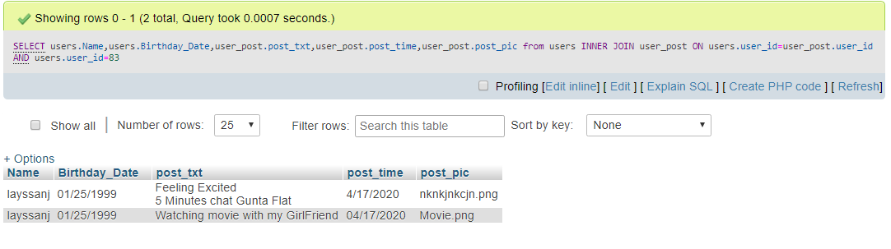

To list all the comments made on the post and the list the name of the user made comment

[SELECT](http://localhost/phpmyadmin/url.php?url=https://dev.mysql.com/doc/refman/5.5/en/select.html) U.Name, U.Gender,P.post_txt,P.post_pic,C.comment FROM users AS U JOIN user_post P ON U.user_id = P.user_id JOIN user_post_comment C ON C.post_id=P.post_id



